Crash Bandicoot Three JS

Final Project

Alessandro Nicolella-Michelangelo Tronti

Interactive Graphics

June 2023

Introduction

The game wants to give to the old-style gamers a throwback into the 90s, when the Crash Bandicoot era begins. It is all WebGL based, for which we’ve used:

* **JavaScript:** to build the logic of the game, with the various object spawns and all the mechanics of the game.
* **HTML+CSS:** for the front-end of the application and menu management.
* **ThreeJS library:** it simplified us the writing process of WebGL applications.
* **TweenJS:** to implement clearer animations for the run of the 3D model.

# Game Idea

The game is inspired by **Crash Bandicoot**, one of the most played video games in the 1990-2000 years. The name is a word pun of the third sequel of the trilogy, Crash Three, with our most used library in the project, **ThreeJS**. Our level starts in a forest near to a pirate bay, which is the level end, where a ship got destroyed and all the stuff on in got tossed all around. The goal of the game is to arrive at the end of the level without lose all the lives, avoiding obstacles, collecting fruits and break special or normal boxes.

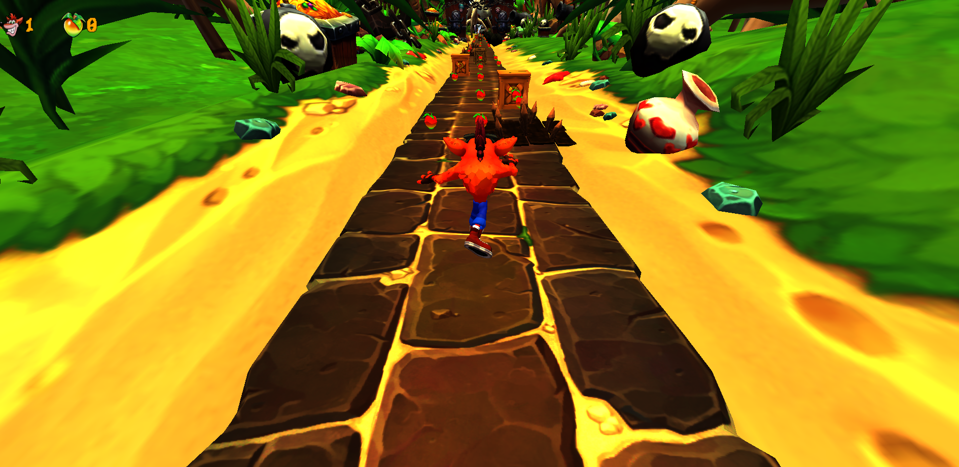

Figure 1: Gameplay

# Development

The development of the project is divided into different parts, so that in each one we can focus on different aspects of the game.

## Main Character: Crash Bandicoot

Crash Bandicoot is the main character that the player can interact with. The 3D model is imported from SketchFab and is made of many parts and bones, that can be manipulated through JavaScript code and ThreeJS, loaded in an array called playerBones. There are almost 150 bones, including fingers and hair of the model, but we used only the parts that moves the model to simulate a run animation effect.

### Heading Three

When citing any quote or text that consists of three or more lines, APA guidelines call for block-quote format:

Create a new paragraph to begin the block-quote. Double-space each line of text, as you have done with headings, section labels, and paragraphs of paraphrased text. To correctly format a block-quote, indent each line of the text to one-half inch. Remember to always cite your source.

Last Name (Year) citations can be used when writing a paper in narrative form. Parenthetical citations are also appropriate (Last Name, Year).

Heading Four: When using headings, don’t skip levels. If you need a heading 3, 4, or 5 with no text following it before the next heading, just add a period at the end of the heading and start a new paragraph for the subheading and its text.

Heading Five. Like all sections of your paper, references start on their own page, like the page that follows this one. All in-text citations should be included your references.